The list of optimal irreducible polynomial m≤ 10

m = 3 x³ + x + 1
m = 4 x⁴ + x + 1
m = 5 x⁵ + x² + 1
m = 6 x⁶ + x + 1
m = 7 x⁷ + x + 1
m = 8 x⁸ + x⁴ + x³ + x² + 1
m = 9 x⁹ + x⁴ + 1
m = 10 x¹⁰ + x³ +1

Polynomial, dual and normal basis representations of GF(2⁴), generated by the irreducible polynomial p(x)= 1 + x + x⁴

power of α | Standard basis  1, α, α², α³ | Dual basis  1, α³, α², α | Normal basis  α³, α⁶, α¹², α⁹
- | 0000 | 0000 | 0000
0 | 1000 | 1000 | 1111
1 | 0100 | 0001 | 1001
2 | 0010 | 0010 | 1100
3 | 0001 | 0100 | 1000
4 | 1100 | 1001 | 0110
5 | 0110 | 0011 | 0101
6 | 0011 | 0110 | 0100
7 | 1101 | 1101 | 1110
8 | 1010 | 1010 | 0011
9 | 0101 | 0101 | 0001
10 | 1110 | 1011 | 1010
11 | 0111 | 0111 | 1101
12 | 1111 | 1111 | 0010
13 | 1011 | 1110 | 1011
14 | 1001 | 1100 | 0111

Optimal dual basis to polynomial basis conversions
Irreducible polynomials p(x) for GF(2^{m}) are given in Appendix A

b dual basis coefficients → a - polynomial basis coefficients [38]
{b₀ μ₀ + b₁ μ₁ + ... + b_{m-1} μ_{m-1}} → {a₀ + a₁ α + ... + a_{m-1} α^{m-1}}
m | a₀ | a₁ | a₂ | a₃ | a₄ | a₅ | a₆ | a₇ | a₈ | a₉
3 | b₀ | b₂ | b₁
4 | b₀ | b₃ | b₂ | b₁
5 | b₁ | b₀ | b₄ | b₃ | b₂
6 | b₀ | b₅ | b₄ | b₃ | b₂ | b₁
7 | b₀ | b₆ | b₅ | b₄ | b₃ | b₂ | b₁
8 | b₂ | b₁ | b₀+b₂ | b₃+b₇ | b₆ | b₅ | b₄ | b₃
9 | b₃ | b₂ | b₁ | b₀ | b₈ | b₇ | b₆ | b₅ | b₄
10 | b₂ | b₁ | b₀ | b₉ | b₈ | b₇ | b₆ | b₅ | b₄ | b₃
In general for:
an irreducible trinomial of the form: x^{m} + x^{p} + 1
a₀, a₁, a₂, ..., a_{m-1} ← b_{p-1}, b_{p-2}, ..., b₀, b_{m-1}, b_{m-2}, ... , b_{p}
an irreducible pentanomial of the form: x^{m} + x^{p+2} + x^{p+1} + x^{p} + 1
a₀, a₁, a₂, ..., a_{m-1} ← b_{p}, b_{p-1}, ..., b₁, b₀ + b_{p}, b_{p+1} + b_{m-1}, b_{m-2}, ... , b_{p+1}

Polynomial basis to dual basis conversions
a - polynomial basis coefficients → b - dual basis coefficients
{a₀ + a₁ α + ... + a_{m-1} α^{m-1}} → {b₀ μ₀ + b₁ μ₁ + ... + b_{m-1} μ_{m-1}}
m | b₀ | b₁ | b₂ | b₃ | b₄ | b₅ | b₆ | b₇ | b₈ | b₉
3 | a₀ | a₂ | a₁
4 | a₀ | a₃ | a₂ | a₁
5 | a₁ | a₀ | a₄ | a₃ | a₂
6 | a₀ | a₅ | a₄ | a₃ | a₂ | a₁
7 | a₀ | a₆ | a₅ | a₄ | a₃ | a₂ | a₁
8 | a₀+a₂ | a₁ | a₀ | a₇ | a₆ | a₅ | a₄ | a₃+a₇
9 | a₃ | a₂ | a₁ | a₀ | a₈ | a₇ | a₆ | a₅ | a₄
10 | a₂ | a₁ | a₀ | a₉ | a₈ | a₇ | a₆ | a₅ | a₄ | a₃

In general for:
an irreducible trinomial of the form: x^{m} + x^{p} + 1
b₀, b₁, b₂, ..., b_{m-1} ← a_{p-1}, a_{p-2}, ..., a₀, a_{m-1}, a_{m-2}, ... , a_{p}
an irreducible pentanomial of the form: x^{m} + x^{p+2} + x^{p+1} + x^{p} + 1
b₀, b₁, b₂, ..., b_{m-1} ← a₀ + a_{p}, a_{p-1}, ..., a₀, a_{m-1}, a_{m-2}, ... , a_{p+2}, a_{p+1} + a_{m-1}

BCH codes generated by primitive elements for m ≤ 10

(n, k, t)
n length of a codeword in bits
k number of information bits in a codeword
t the maximum number of errors that can be corrected

m= 3
(7, 4, 1)

m= 4
(15, 11, 1) (15, 7, 2) (15, 5, 3)

m= 5
(31, 26, 1) (31, 21, 2) (31, 16, 3) (31, 11, 5)
(31, 6, 7)

m= 6
(63, 57, 1) (63, 51, 2) (63, 45, 3) (63, 39, 4)
(63, 36, 5) (63, 30, 6) (63, 24, 7) (63, 18, 10)
(63, 16, 11) (63, 10, 13) (63, 7, 15)

m= 7
(127, 120, 1) (127, 113, 2) (127, 106, 3) (127, 99, 4)
(127, 92, 5) (127, 85, 6) (127, 78, 7) (127, 71, 9)
(127, 64, 10) (127, 57, 11) (127, 50, 13) (127, 43, 14)
(127, 36, 15) (127, 29, 21) (127, 22, 23) (127, 15, 27)
(127, 8, 31)

m= 8
(255, 247, 1) (255, 239, 2) (255, 231, 3) (255, 223, 4)
(255, 215, 5) (255, 207, 6) (255, 199, 7) (255, 191, 8)
(255, 187, 9) (255, 179, 10) (255, 171, 11) (255, 163, 12)
(255, 155, 13) (255, 147, 14) (255, 139, 15) (255, 131, 18)
(255, 123, 19) (255, 115, 21) (255, 107, 22) (255, 99, 23)
(255, 91, 25) (255, 87, 26) (255, 79, 27) (255, 71, 29)
(255, 63, 30) (255, 55, 31) (255, 47, 42) (255, 45, 43)
(255, 37, 45) (255, 29, 47) (255, 21, 55) (255, 13, 59)
(255, 9, 63)

m= 9
(511, 502, 1) (511, 493, 2) (511, 484, 3) (511, 475, 4)
(511, 466, 5) (511, 457, 6) (511, 448, 7) (511, 439, 8)
(511, 430, 9) (511, 421, 10) (511, 412, 11) (511, 403, 12)
(511, 394, 13) (511, 385, 14) (511, 376, 15) (511, 367, 17)
(511, 358, 18) (511, 349, 19) (511, 340, 20) (511, 331, 21)
(511, 322, 22) (511, 313, 23) (511, 304, 25) (511, 295, 26)
(511, 286, 27) (511, 277, 28) (511, 268, 29) (511, 259, 30)
(511, 250, 31) (511, 241, 36) (511, 238, 37) (511, 229, 38)
(511, 220, 39) (511, 211, 41) (511, 202, 42) (511, 193, 43)
(511, 184, 45) (511, 175, 46) (511, 166, 47) (511, 157, 51)
(511, 148, 53) (511, 139, 54) (511, 130, 55) (511, 121, 58)
(511, 112, 59) (511, 103, 61) (511, 94, 62) (511, 85, 63)
(511, 76, 85) (511, 67, 87) (511, 58, 91) (511, 49, 93)
(511, 40, 95) (511, 31, 109) (511, 28, 111) (511, 19, 119)
(511, 10, 127)

m= 10
(1023, 1013, 1) (1023, 1003, 2) (1023, 993, 3) (1023, 983, 4)
(1023, 973, 5) (1023, 963, 6) (1023, 953, 7) (1023, 943, 8)
(1023, 933, 9) (1023, 923, 10) (1023, 913, 11) (1023, 903, 12)
(1023, 893, 13) (1023, 883, 14) (1023, 873, 15) (1023, 863, 16)
(1023, 858, 17) (1023, 848, 18) (1023, 838, 19) (1023, 828, 20)
(1023, 818, 21) (1023, 808, 22) (1023, 798, 23) (1023, 788, 24)
(1023, 778, 25) (1023, 768, 26) (1023, 758, 27) (1023, 748, 28)
(1023, 738, 29) (1023, 728, 30) (1023, 718, 31) (1023, 708, 34)
(1023, 698, 35) (1023, 688, 36) (1023, 678, 37) (1023, 668, 38)
(1023, 658, 39) (1023, 648, 41) (1023, 638, 42) (1023, 628, 43)
(1023, 618, 44) (1023, 608, 45) (1023, 598, 46) (1023, 588, 47)
(1023, 578, 49) (1023, 573, 50) (1023, 563, 51) (1023, 553, 52)
(1023, 543, 53) (1023, 533, 54) (1023, 523, 55) (1023, 513, 57)
(1023, 503, 58) (1023, 493, 59) (1023, 483, 60) (1023, 473, 61)
(1023, 463, 62) (1023, 453, 63) (1023, 443, 73) (1023, 433, 74)
(1023, 423, 75) (1023, 413, 77) (1023, 403, 78) (1023, 393, 79)
(1023, 383, 82) (1023, 378, 83) (1023, 368, 85) (1023, 358, 86)
(1023, 348, 87) (1023, 338, 89) (1023, 328, 90) (1023, 318, 91)
(1023, 308, 93) (1023, 298, 94) (1023, 288, 95) (1023, 278, 102)
(1023, 268, 103) (1023, 258, 106) (1023, 248, 107) (1023, 238, 109)
(1023, 228, 110) (1023, 218, 111) (1023, 208, 115) (1023, 203, 117)
(1023, 193, 118) (1023, 183, 119) (1023, 173, 122) (1023, 163, 123)
(1023, 153, 125) (1023, 143, 126) (1023, 133, 127) (1023, 123, 170)
(1023, 121, 171) (1023, 111, 173) (1023, 101, 175) (1023, 91, 181)
(1023, 86, 183) (1023, 76, 187) (1023, 66, 189) (1023, 56, 191)
(1023, 46, 219) (1023, 36, 223) (1023, 26, 239) (1023, 16, 247)
(1023, 11, 255)

bold - n < (m+2) * t -2: interleave = 2 (see Section 4.4.3.1)
bold italic - 2n < (m+2) * t -2: interleave = 3

Encoder control system - the illustration how the C program, templates and VHDL files work together
C program

/* The function for coping a template into a VHDL file. */
void
CopyFile(fin, fout) /* fin -an input (template) file, fout -an output (VHDL) file*/
FILE *fin, *fout; /* variable declarations */
{ char c;
c=getc(fin); /* read a character from the input file */
while(c!='#' && c!=EOF) /* while the read character is not ‘#’ or End Of File*/
{ putc(c,fout); c= getc(fin); } /* copy the input file into the output file */
}

/* Print an ‘And’ statement that =1 if cout== i for a finite field counter */
void
PrintAndCout(fo, i)
FILE *fo;
int i;
{ int f, mask, lx;
lx=LPow(i); /* lx=α^{i} =a₀ , a₁α¹,... , a_{m-1}α^{m-1} */
mask=one; /* the mask equals α⁰ */
if((mask & lx)==0) fprintf(fo," NOT"); /* if a₀ bit of lx is zero print NOT */
fprintf(fo, " cout(0)"); /* print to the file “ cout(0)” */
mask>>=1; /* shift the mask to represent the α^{j+1} bit */
for(f=1; f<m; f++)
{ fprintf(fo," AND");
if((mask & lx)==0) fprintf(fo," NOT"); /* if the a_{f} bit of lx is zero print ‘NOT’ */
fprintf(fo, " cout(%d)",f); /* print to the file “ cout(f)” */
mask>>=1; /* shift the mask to represent the α^{j+1} bit */
}
}

/* Print a LFSR for a counter */
void
PrintCoutRing(fo)
FILE *fo;
{ int f, mask;
mask=one; mask>>=1; /* the mask =x¹ */
for(f=1; f<m; f++)
{ if(mask & gen_basis)/*gen_basis -the irreducible polynomial in GF(2^{m}) (Appendix A)*/
fprintf(fo,"\tcout(%d)<= (cout(%d) XOR cout(m-1)) AND NOT reset;\n",f,f-1);
else
fprintf(fo,"\tcout(%d)<= cout(%d) AND NOT reset;\n",f,f-1);
mask>>=1; /* mask = x^{f+1} */
} }

Fragment of C executable program
...
CopyFile(fi,fo); /* the beginning ecount*/
PrintAndCout(fo,k-1); /* for the vdinR signal the ‘AND’ statement */
CopyFile(fi,fo);
PrintAndCout(fo,n-1); /* for the vdinS signal the ‘AND’ statement */
CopyFile(fi,fo);
PrintCoutRing(fo); /* for a LFSR in a counter */
CopyFile(fi,fo); /* finishing ecount and beginning enc */
...

Template
The fragment of the bch.vht template for a counter modulo 15 (using multiplication by α) for the (15, 5) BCH code encoder.

-- COUNTER MODULO n FOR the (n,k) BCH ENCODER

USE WORK.const.ALL;
ENTITY ecount IS
PORT (clk, reset: IN BIT;
vdin: OUT BIT); --vdin - valid data in - vdin=1 if 0 ≤ count < k
END ecount;

ARCHITECTURE ecounta OF ecount IS
SIGNAL cout: BIT_VECTOR(0 TO m-1); -- cout in GF(2^m); cout= L^count
SIGNAL vdinR, vdinS, vdin1: BIT;
BEGIN
vdinR<=#; -- Run PrintAndCout(fo,k-1) C function
-- synchronous reset of vdin1 register if cout==k-1
vdinS<= (#) OR reset; -- Run PrintAndCout(fo,n-1) C function
-- synchronous set vdinS=1 if cout==n-1
vdin<= vdin1 AND NOT reset; -- output signal vdin is related with vdin1 register

PROCESS BEGIN -- vdin1 register circuit
WAIT UNTIL clk'EVENT AND clk='1';
IF vdinR='1' THEN
vdin1<= '0';
ELSIF vdinS='1' THEN
vdin1<= '1';
END IF;
END PROCESS;

PROCESS BEGIN -- increment or reset the cout in the LFSR, cout=L^count
WAIT UNTIL clk'EVENT AND clk='1';
cout(0)<= cout(m-1) OR reset;
# END PROCESS; -- run PrintCoutRing(fo) C function
END ecounta;

VHDL
The fragment of the enc.vhd file for the control system for an encoder
-- COUNTER MODULO n FOR the (n,k) BCH ENCODER

USE WORK.const.ALL;
ENTITY ecount IS
PORT (clk, reset: IN BIT;
vdin: OUT BIT); --vdin - valid data in - vdin=1 if 0 ≤ count < k
END ecount;

ARCHITECTURE ecounta OF ecount IS
SIGNAL cout: BIT_VECTOR(0 TO m-1); -- cout in GF(2^m); cout= L^count
SIGNAL vdinR, vdinS, vdin1: BIT;
BEGIN
vdinR<= cout(0) AND cout(1) AND NOT cout(2) AND NOT cout(3);
-- the synchronous reset of the vdin1 register if cout==k-1
vdinS<= ( cout(0) AND NOT cout(1) AND NOT cout(2) AND cout(3)) OR reset;
-- the synchronous set of the vdinS=1 if cout==n-1
vdin<= vdin1 AND NOT reset; -- output signal vdin is related with vdin1 register

PROCESS BEGIN -- the vdin1 register circuit
WAIT UNTIL clk'EVENT AND clk='1';
IF vdinR='1' THEN
vdin1<= '0';
ELSIF vdinS='1' THEN
vdin1<= '1';
END IF;
END PROCESS;

PROCESS BEGIN -- increment or reset the cout in the LFSR, cout=L^count
WAIT UNTIL clk'EVENT AND clk='1';
cout(0)<= cout(m-1) OR reset;
cout(1)<= (cout(0) XOR cout(m-1)) AND NOT reset;
cout(2)<= cout(1) AND NOT reset;
cout(3)<= cout(2) AND NOT reset;
END PROCESS;
END ecounta;

Constant values file: const.vhd
for a (15, 5) triple error correcting BCH code.

-- File generated by bch.exe program.
-- The constant package for BCH code (15,5), t=3
-- Option= 3, Interleave= 2, -- with optimisation.
-- GF(2^4) is generated by polynomial [1+x+...] - 11001;
-- Constants necessary for the decoder and encoder

PACKAGE const IS
CONSTANT m: INTEGER:= 4;
CONSTANT n: INTEGER:= 15; -- n= 2^m -1 -size of block
CONSTANT k: INTEGER:= 5; -- BCH code (n,k) -no. of information bits
CONSTANT nk: INTEGER:= 10; -- nk=n-k
CONSTANT t: INTEGER:= 3; -- no. of errors to be corrected

CONSTANT sizea: INTEGER:= 3; -- size of counter ca
CONSTANT sizeb: INTEGER:= 3; -- size of counter cb
-- count = iteration* cb + ca
CONSTANT sizel: INTEGER:= 3;
-- size of l register (degree of error polynomial in the BMA)
END const;

The (15,5) BCH code encoder
LFSR for the encoder

USE WORK.const.ALL;
ENTITY ering IS
PORT (clk, rll, din: IN BIT; -- rll - ring loop lock (feedback enable)
dout: OUT BIT); --output serial data
END ering;

ARCHITECTURE eringa OF ering IS
SIGNAL rin, rout: BIT_VECTOR(0 TO nk-1); -- ring register
SIGNAL rin0: BIT;
BEGIN
dout<= rout(nk-1);
rin0 <= (din XOR rout(nk-1)) AND rll;
rin(0)<= rin0;
rin(1)<= rout(0) XOR rin0;
rin(2)<= rout(1) XOR rin0;
rin(3)<= rout(2);
rin(4)<= rout(3) XOR rin0;
rin(5)<= rout(4) XOR rin0;
rin(6)<= rout(5);
rin(7)<= rout(6);
rin(8)<= rout(7) XOR rin0;
rin(9)<= rout(8);
-- Polynomial generating encoder: a0+a1*x+a2*x^2+...
-- 11101100101
-- Number of XOR gates= 5

PROCESS BEGIN
WAIT UNTIL clk'EVENT AND clk='1';
rout<= rin;
END PROCESS;
END eringa;

Ecount entity has been presented in Appendix E.

-----------------------------------------------------------------
-- ENCODER

USE WORK.const.ALL;
ENTITY enc IS
PORT (clk, reset, din: IN BIT;
vdin, dout: OUT BIT); --dout- serial data output to be transmitted
END enc; -- vdin - valid data in (input of information bits is enable)-
-- to enable external data shifting

ARCHITECTURE enca OF enc IS
SIGNAL vdin1, rin, rout, rll: BIT;
-- rll-ring loop lock, rin -ring (LFSR) in, rout - ring out

COMPONENT ecount --counter encoder
PORT(clk, reset: IN BIT; vdin: OUT BIT);
END COMPONENT;
FOR ALL: ecount USE ENTITY WORK.ecount (ecounta);
COMPONENT ering --ring for encoder (LFSR)
PORT(clk, rll, din: IN BIT; dout: OUT BIT);
END COMPONENT;
FOR ALL: ering USE ENTITY WORK.ering (eringa);
BEGIN
c1: ecount
PORT MAP (clk, reset, vdin1);
r1: ering
PORT MAP (clk, rll, rin, rout);
rin<= din AND NOT reset;
rll<= vdin1 AND NOT reset;
vdin<= vdin1;

PROCESS BEGIN
WAIT UNTIL clk'EVENT AND clk='1';
dout<= (NOT vdin1 AND rout) OR (vdin1 AND rin); -- the output register
END PROCESS;
END enca;

Calculation of the syndromes for the (15, 5) BCH code
USE WORK.const.ALL; -- syndromes S₁, S₂, S₄ - calculated in the
-- the second way
-- the minimal polynomial f₁(x) = 1 + x + x⁴.
ENTITY dsyn1 IS
PORT (clk, ce, pe ,din: IN BIT;
dout1, dout2, dout4: OUT BIT_VECTOR(0 TO m-1));
END dsyn1;

ARCHITECTURE dsyn1a OF dsyn1 IS
SIGNAL syn: BIT_VECTOR(0 TO 5);
BEGIN
syn(4)<= syn(1) XOR syn(3); -- 2
syn(5)<= syn(0) XOR syn(2); -- 1
-- Saving due to optimisation = 3
dout1(0 TO m-1)<= syn(0 TO m-1);
dout2(0)<= syn(5);
dout2(1)<= syn(2);
dout2(2)<= syn(4);
dout2(3)<= syn(3);
dout4(0)<= syn(4) XOR syn(5);
dout4(1)<= syn(4);
dout4(2)<= syn(2) XOR syn(3);
dout4(3)<= syn(3);
PROCESS BEGIN
WAIT UNTIL clk'EVENT AND clk='1';
IF pe='1' THEN
syn(0)<= din;
syn(1 TO 3)<= "000";
ELSIF ce='1' THEN
syn(0)<= syn(3) XOR din;
syn(1)<= syn(0) XOR syn(3);
syn(2)<= syn(1);
syn(3)<= syn(2);
END IF;
END PROCESS;
END dsyn1a;

USE WORK.const.ALL; -- S₃ - calculated in the first way *α³
ENTITY dsyn3 IS
PORT (clk, ce, pe ,din: IN BIT;
dout3: OUT BIT_VECTOR(0 TO m-1));
END dsyn3;

ARCHITECTURE dsyn3a OF dsyn3 IS
SIGNAL syn: BIT_VECTOR(0 TO 3);
BEGIN
dout3<= syn;
PROCESS BEGIN
WAIT UNTIL clk'EVENT AND clk='1';
IF pe='1' THEN
syn(0)<= din;
syn(1 TO 3)<= "000";
ELSIF ce='1' THEN
syn(0)<= din XOR syn(1);
syn(1)<= syn(1) XOR syn(2);
syn(2)<= syn(2) XOR syn(3);
syn(3)<= syn(0) XOR syn(3);
END IF;
END PROCESS;
END dsyn3a;

USE WORK.const.ALL; -- S₅ - in the second way
-- the minimal polynomial f₃(x) = 1 + x - the degree of the polynomial
-- is less than m thus only 2 (not 4) registers are required,
-- and the second way of the syndrome calculation is selected
ENTITY dsyn5 IS
PORT (clk, ce, pe ,din: IN BIT;
dout5: OUT BIT_VECTOR(0 TO m-1));
END dsyn5;

ARCHITECTURE dsyn5a OF dsyn5 IS
SIGNAL syn: BIT_VECTOR(0 TO 1);
BEGIN
-- Saving due to optimisation = 0
dout5(0)<= syn(0);
dout5(1)<= syn(1);
dout5(2)<= syn(1);
dout5(3)<= '0';
PROCESS BEGIN
WAIT UNTIL clk'EVENT AND clk='1';
IF pe='1' THEN
syn(0)<= din;
syn(1 TO 1)<= "0";
ELSIF ce='1' THEN
syn(0)<= syn(1) XOR din;
syn(1)<= syn(0) XOR syn(1);
END IF;
END PROCESS;
END dsyn5a;

Chien search for the (15,5) BCH code
USE WORK.const.ALL;
ENTITY dch1 IS -- for x^1
PORT (clk, ce, pe: IN BIT;
din: IN BIT_VECTOR(0 TO m-1);
dout: OUT BIT_VECTOR(0 TO m-1));
END dch1;

ARCHITECTURE dch1a OF dch1 IS
SIGNAL chin: BIT_VECTOR(0 TO m-1); -- registers input
SIGNAL ch: BIT_VECTOR(0 TO 3); -- ch registers and optimisation
BEGIN
dout<= ch(0 TO m-1);
chin(0)<= ch(3);
chin(1)<= ch(0) XOR ch(3);
chin(2)<= ch(1);
chin(3)<= ch(2);
PROCESS BEGIN
WAIT UNTIL clk'EVENT AND clk='1';
IF pe='1' THEN
ch(0 TO m-1)<= din;
ELSIF ce='1' THEN
ch(0 TO m-1)<= chin;
END IF;
END PROCESS; -- the number of XOR gates= 1;
END dch1a;

USE WORK.const.ALL;
ENTITY dch2 IS -- for x^2
PORT (clk, ce, pe: IN BIT;
din: IN BIT_VECTOR(0 TO m-1);
dout: OUT BIT_VECTOR(0 TO m-1));
END dch2;

ARCHITECTURE dch2a OF dch2 IS
SIGNAL chin: BIT_VECTOR(0 TO m-1); -- registers input
SIGNAL ch: BIT_VECTOR(0 TO 3); -- ch registers and optimisation
BEGIN
dout<= ch(0 TO m-1);
chin(0)<= ch(2);
chin(1)<= ch(2) XOR ch(3);
chin(2)<= ch(0) XOR ch(3);
chin(3)<= ch(1);
PROCESS BEGIN
WAIT UNTIL clk'EVENT AND clk='1';
IF pe='1' THEN
ch(0 TO m-1)<= din;
ELSIF ce='1' THEN
ch(0 TO m-1)<= chin;
END IF;
END PROCESS; -- the number of XOR gates= 2;
END dch2a;

USE WORK.const.ALL;
ENTITY dch3 IS
PORT (clk, ce, pe: IN BIT;
din: IN BIT_VECTOR(0 TO m-1);
dout: OUT BIT_VECTOR(0 TO m-1));
END dch3;

ARCHITECTURE dch3a OF dch3 IS
SIGNAL chin: BIT_VECTOR(0 TO m-1); -- registers input
SIGNAL ch: BIT_VECTOR(0 TO 3); -- ch registers and optimisation
BEGIN
dout<= ch(0 TO m-1);
chin(0)<= ch(1);
chin(1)<= ch(1) XOR ch(2);
chin(2)<= ch(2) XOR ch(3);
chin(3)<= ch(0) XOR ch(3);
PROCESS BEGIN
WAIT UNTIL clk'EVENT AND clk='1';
IF pe='1' THEN
ch(0 TO m-1)<= din;
ELSIF ce='1' THEN
ch(0 TO m-1)<= chin;
END IF;
END PROCESS; -- the number of XOR gates= 3;
END dch3a;
------------------------------------------------------------------------
USE WORK.const.ALL;
ENTITY dcheq IS -- Find if chien search circuit equals 0
PORT (din1, din2, din3: IN BIT_VECTOR(0 TO m-1);
dout: OUT BIT); -- dout=1 if equals zero
END dcheq;

ARCHITECTURE dcheqa OF dcheq IS
SIGNAL eq: BIT_VECTOR(0 TO m-1);
BEGIN
eq(0)<= NOT din1(0) XOR din2(0) XOR din3(0);
--’NOT’ because ch0=“1000”
eq(1)<= din1(1) XOR din2(1) XOR din3(1);
eq(2)<= din1(2) XOR din2(2) XOR din3(2);
eq(3)<= din1(3) XOR din2(3) XOR din3(3);
dout<= NOT (eq(0) OR eq(1) OR eq(2) OR eq(3));
END dcheqa;

Raising to the power three in GF(2⁵) with design optimisation
VHDL entity for exponentiation to the power 3 in GF(2⁵) with design optimisation
ENTITY dpow3 IS
PORT (din: IN BIT_VECTOR(0 TO m-1);
dout: OUT BIT_VECTOR(0 TO m-1));
END dpow3;

ARCHITECTURE dpow3a OF dpow3 IS
SIGNAL dxor: BIT_VECTOR(0 TO 21);
BEGIN
dxor(0 TO m-1)<= din;
dxor(5)<= din(0) AND din(1);
dxor(6)<= din(0) AND din(2);
dxor(7)<= din(0) AND din(3);
dxor(8)<= din(0) AND din(4);
dxor(9)<= din(1) AND din(2);
dxor(10)<= din(1) AND din(3);
dxor(11)<= din(1) AND din(4);
dxor(12)<= din(2) AND din(3);
dxor(13)<= din(2) AND din(4);
dxor(14)<= din(3) AND din(4);
dxor(15)<= dxor(8) XOR dxor(9); -- 2
dxor(16)<= dxor(2) XOR dxor(3); -- 1
dxor(17)<= dxor(4) XOR dxor(5); -- 1
dxor(18)<= dxor(6) XOR dxor(13); -- 1
dxor(19)<= dxor(10) XOR dxor(12); -- 1
dxor(20)<= dxor(14) XOR dxor(15); -- 1
dxor(21)<= dxor(18) XOR dxor(20); -- 1
-- optimisation saving = 8 XOR gates
dout(0)<= dxor(0) XOR dxor(15) XOR dxor(19);
dout(1)<= dxor(7) XOR dxor(14) XOR dxor(16) XOR dxor(17);
dout(2)<= dxor(17) XOR dxor(21);
dout(3)<= dxor(1) XOR dxor(4) XOR dxor(8) XOR dxor(12) XOR dxor(13) XOR dxor(16);
dout(4)<= dxor(3) XOR dxor(11) XOR dxor(19) XOR dxor(21);
-- 21 XOR gates
END dpow3a;

Bit-parallel multiplications
Common SDBM, VHDL (the serial dual basis multiplier)
USE WORK.const.ALL;
ENTITY dsdbm IS
PORT (dbin, sbin: IN BIT_VECTOR(0 TO m-1); -- standard & dual basis input
dout: OUT BIT); -- serial output
END dsdbm;

ARCHITECTURE dsdbma OF dsdbm IS
SIGNAL dxor: BIT_VECTOR(0 TO m-1); -- xor gates signals
BEGIN
dout<= dxor(m-1);
dxor(0)<= sbin(0) AND dbin(0);
gen:
FOR i IN 1 TO m-1 GENERATE
dxor(i)<= dxor(i-1) XOR (sbin(i) AND dbin(i));
END GENERATE;
END dsdbma;

Parallel Dual basis multiplier in GF(2⁴)
USE WORK.const.ALL;
ENTITY dpdbm IS
PORT (ddin, dsin: IN BIT_VECTOR(0 TO m-1);
dout: OUT BIT_VECTOR(0 TO m-1));
END dpdbm;

ARCHITECTURE dpdbma OF dpdbm IS
SIGNAL a: BIT_VECTOR(0 TO 2*m-2);
COMPONENT dsdbm -- Serial Dual Basis Multiplier without registers
PORT (dbin, sbin: IN BIT_VECTOR(0 TO m-1);
-- dual & standard basis in
dout: OUT BIT);
END COMPONENT;
FOR ALL: dsdbm USE ENTITY WORK.dsdbm (dsdbma);

BEGIN
a(0 TO m-1)<= ddin;
a(4)<= a(0) XOR a(1);
a(5)<= a(1) XOR a(2);
a(6)<= a(2) XOR a(3);
m0: dsdbm
PORT MAP (a(0 TO 3), dsin, dout(0));
m1: dsdbm
PORT MAP (a(1 TO 4), dsin, dout(1));
m2: dsdbm
PORT MAP (a(2 TO 5), dsin, dout(2));
m3: dsdbm
PORT MAP (a(3 TO 6), dsin, dout(3));

END dpdbma;

Standard basis multiplier, PSBML in GF(2⁴)
USE WORK.const.ALL;
ENTITY dpm IS
PORT (din1, din2: IN BIT_VECTOR(0 TO m-1);
dout: OUT BIT_VECTOR(0 TO m-1));
END dpm;

ARCHITECTURE dpma OF dpm IS
COMPONENT dsdbm -- the Serial Dual Basis Multiplier (without registers)
PORT (dbin, sbin: IN BIT_VECTOR(0 TO m-1);
-- dual & standard basis in
dout: OUT BIT);
END COMPONENT;
FOR ALL: dsdbm USE ENTITY WORK.dsdbm (dsdbma);

SIGNAL b: BIT_VECTOR(0 TO 6); -- in the approach presented in Section 2.5.3
-- m bit_vectors(0 to m-1) are required. But it can be seen that most of this signals
-- are the same. Therefore in this approach only different signals are considered.
-- Therefore the number of the b signal bits is m+(m-1)*(H(pp)-2)
SIGNAL c0, c1, c2, c3: BIT_VECTOR(0 TO m-1);
BEGIN
b(0 TO m-1)<= din1;
b(4)<= b(0) XOR b(3);
b(5)<= b(3) XOR b(2);
b(6)<= b(2) XOR b(1);
c0<= b(0) & b(3) & b(2) & b(1);
m0: dsdbm
PORT MAP (din2, c0, dout(0));
c1<= b(1) & b(4) & b(5) & b(6);
m1: dsdbm
PORT MAP (din2, c1, dout(1));
c2<= b(2) & b(1) & b(4) & b(5);
m2: dsdbm
PORT MAP (din2, c2, dout(2));
c3<= b(3) & b(2) & b(1) & b(4);
m3: dsdbm
PORT MAP (din2, c3, dout(3));
END dpma;

Finite field inversion
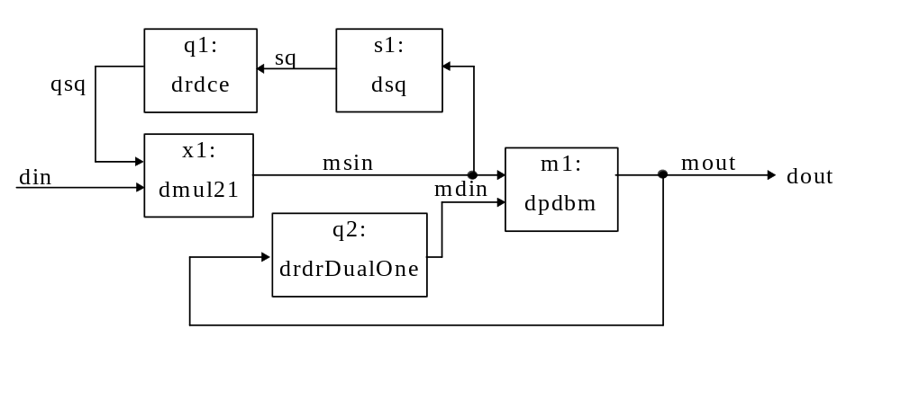
The circuit for carrying out the Fermat inversion and bit-parallel multiplication.

q1: drdce - m * registers with clock enable
s1: dsq - squaring in the polynomial basis
x1: dmul21 - m * (2:1 multiplexer)
m1: dpdbm -the bit-parallel dual basis multiplier (see Appendix K).
q2: drsrDualOne- m* registers with clock enable, synchronous reset to the dual basis value 1, e.g. for m=5, reset value = 01000.

clock | algorithm
0 | mdin← 1; msin= din_{r}; qsq← din_{r}²
1- m-2 | msin = qsq; qsq ← qsq²; mdin ← mdin * msin
m-1 | msin = qsq; mdin← mdin * msin, dout= din_{r}⁻¹
m | msin = din_{r+1}; qsq ← din_{r+1}² ; mdin= din_{r}⁻¹;  dout = din_{r}⁻¹ * din_{r+1}; mdin ← 1;

Single error correcting decoders

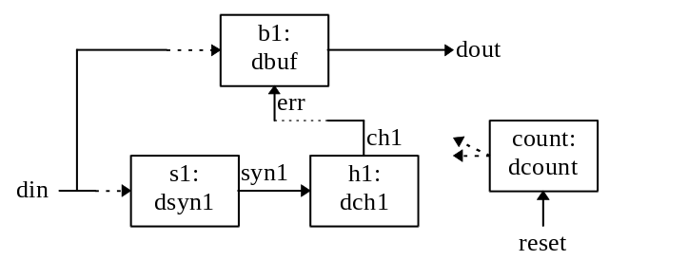
The block diagram for SEC decoders.

The fragment of sim.txt file for a (15, 11) BCH code decoder:

entity name - description
the numbers of used registers and 2 input XOR gates

dcount - counter - control system
Reg= 4 XOR= 1
dsyn1 - syndromes 1
Reg= 4 XOR= 2
dch1 - Chien Search for x^1
Reg= 4 XOR= 1
dbuf - buffer for data to be corrected
Reg= 17 XOR= 1
dec - DECODER
total Reg= 29 XOR= 5

Double error correcting decoders
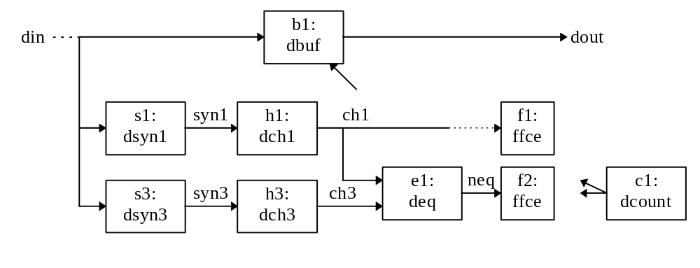
The block diagram for DEC decoders.

The fragment of sim.txt file for a (15, 7) BCH code decoder:

ffce - flip flop register
Reg= 1 XOR= 0
dcount - counter - control system
Reg= 4 XOR= 1
dbuf - buffer for data to be corrected
Reg= 17 XOR= 1

----SYNDROMES----
dsyn1 - syndromes 1
Reg= 4 XOR= 2
dsyn3 - syndromes 3
Reg= 4 XOR= 4
SYNDROMES -- total
total Reg= 8 XOR= 6

---- Chien search ----
dpow3 - dout<= din^3
Reg= 0 XOR= 13
deq - comparison dout<= 1 if (ch1)^3== ch3 - this entity includes dpow3 entity
Reg= 0 XOR= 4
total Reg= 0 XOR= 17
dch1 - Chien Search for x^1
Reg= 4 XOR= 1
dch3 - Chien Search for x^3
Reg= 4 XOR= 3
CHIEN SEARCH - total including dcheq
total Reg= 8 XOR= 21

------ DECODER ------
total Reg= 38 XOR= 29

Fragment of VHDL for (15,7) DEC code.

Chien search - this circuit is similar as for general case, but requires two additional input signals, for assumption that an error has occurred (errcheck) and for correction the error if it has been found (err).

USE WORK.const.ALL;
ENTITY dch3 IS
PORT (clk, err, errcheck, pe: IN BIT;
din: IN BIT_VECTOR(0 TO m-1);
dout: OUT BIT_VECTOR(0 TO m-1));
END dch3;

ARCHITECTURE dch3a OF dch3 IS
SIGNAL ch0reg: BIT;
SIGNAL chin: BIT_VECTOR(0 TO m-1); -- registers input
SIGNAL ch: BIT_VECTOR(0 TO 3); -- ch registers and optimisation
BEGIN
ch0reg<= ch(0) XOR err; -- error was found so correct it
dout(0)<= ch(0) XOR errcheck; -- suppose that an error has occurred
dout(1 TO m-1)<= ch(1 TO m-1);
chin(0)<= ch(1);
chin(1)<= ch(1) XOR ch(2);
chin(2)<= ch(2) XOR ch(3);
chin(3)<= ch0reg XOR ch(3);
PROCESS BEGIN
WAIT UNTIL clk'EVENT AND clk='1';
IF pe='1' THEN
ch(0 TO m-1)<= din;
ELSE
ch(0 TO m-1)<= chin;
END IF;
END PROCESS;
-- number XOR gates= 3;
END dch3a;

The main entity

-- the decoder circuit
USE WORK.const.ALL;
ENTITY dec IS
PORT (clk, reset, din: IN BIT;
vdout, dout: OUT BIT); --vdout - valid data out
END dec;

ARCHITECTURE deca OF dec IS
SIGNAL pe, cef, cefa, vdout1, din_reset: BIT;
--pe -parallel enable for Chien search and reset for dsyn;
-- cef- ce
SIGNAL ff1, ff3, err, err1, err2, errcheck, neq: BIT;
-- ff1, ff3 registers to remember previous number of errors
-- err - correct error, err1 - single error found, err2- double
-- errcheck - assumption that an error has occurred (should be zero for initialisation)
SIGNAL syn1, syn3: BIT_VECTOR(0 TO m-1); -- syndromes
SIGNAL ch1, ch3: BIT_VECTOR(0 TO m-1); -- Chien search output
SIGNAL ch1_or: BIT_VECTOR(0 TO m-1); -- for sum of ch1
... declaration of components
...
BEGIN
c1: dcount
PORT MAP (clk, reset, cef, pe, vdout, vdout1);
b1: dbuf
PORT MAP (clk, err, vdout1, din_reset, dout);
e1: deq
PORT MAP (ch1, ch3, neq);
f1: ffce
PORT MAP (clk, cefa, ch1_or(m-1), ff1);
f2: ffce
PORT MAP (clk, cefa, neq, ff3);
s1: dsyn1
PORT MAP (clk, pe, din_reset, syn1);
s3: dsyn3
PORT MAP (clk, pe, din_reset, syn3);
h1: dch1
PORT MAP (clk, err, errcheck, pe, syn1, ch1);
h3: dch3
PORT MAP (clk, err, errcheck, pe, syn3, ch3);

din_reset<= din AND NOT reset;

-- ch1_or eq_or gates
ch1_or(0)<= ch1(0);
gen:
FOR i IN 1 TO m-1 GENERATE
ch1_or(i)<= ch1_or(i-1) OR ch1(i);
END GENERATE;

-- cefa - clock enable p1, p3 - cefa=1 if start of a new word or err
cefa <= cef OR err;
-- error decision circuit
err1<= NOT ff3 AND NOT neq AND ff1 AND NOT ch1_or(m-1);
--single err
err2<= ff1 AND ch1_or(m-1) AND ff3 AND NOT neq;
-- double error
err<= err1 OR err2; -- error has been found
errcheck<= NOT cef; --
END deca;

TMEC decoders and the BMA with inversion
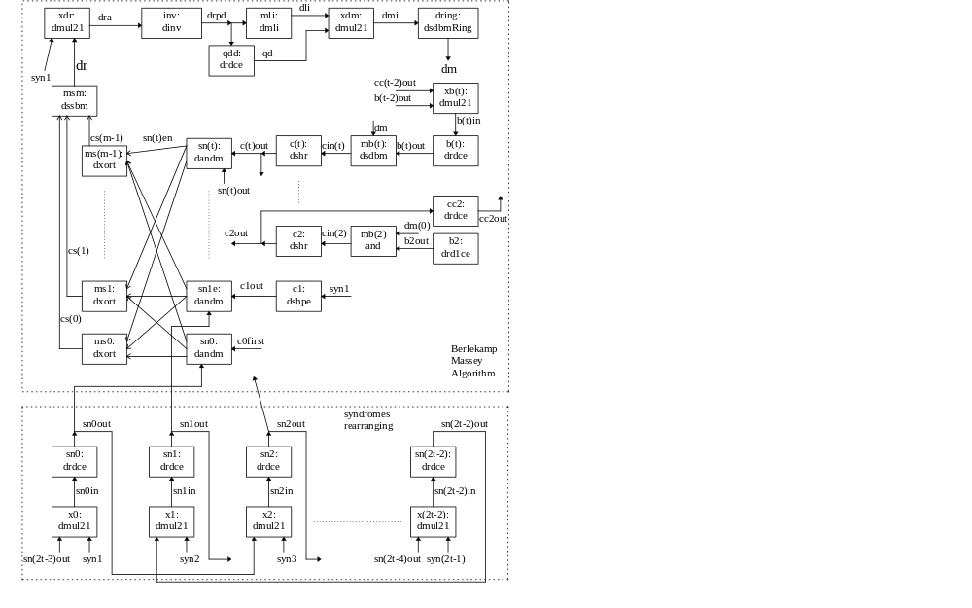 The circuit for the BMA with inversion
The description of the BMA entities.
xdr - 2:1 multiplexer to initialise the inverter with S₁ value (if S₁ ≠0) (see equ(3.17))
inv - inverter /division drpd<= dra _{current}/dra _{previous} (see Appendix L)
drpd- the dual basis representation, drpd- the polynomial basis representation.
mli, qdd, xdm, dring - the basis rearranging circuit (see Fig. 2.9) for m≠8
b(i) - registers to store value β(x)= b₂x² + ... +b_{i}x^{i} + ... b_{t}x^{t} (see equ(3.18))
xb(i) - 2:1 multiplexer for selecting the new value of β^{(r+1)}(x)
mb(i) - the SDBM (without registers) (see Fig. 2.9) for multiplication d_{rp}⋅β_{i}(x) (equ(4.3))
c(i) - registers to store values σ_{i} (similar to registers C₀₋₃ on Fig. 2.9) with summation
cc(i) - registers to store the previous value of the c_{i} registers
sn(i) - m 2-input AND gates for the multiplication S_{j}⋅σ_{i}.
ms(i) - (t-1) XOR gates for the summation in the Sum of Products architecture (see Fig2.6)
msm - the LFSR for the Sum of Products (part A)

The fragment of the sim.txt file for a decoder of the (63, 18) 10 error correction BCH code option 3 with inversion (with design optimisation):
--------------- Syndromes calculation ------------
dsyn1 - syndromes 1 2 4 8 16
Reg= 6 XOR= 15
dsyn3 - syndromes 3 6 12
Reg= 6 XOR= 14
dsyn5 - syndromes 5 10 17
Reg= 6 XOR= 14
dsyn7 - syndromes 7 14
Reg= 6 XOR= 12
dsyn9 - syndromes 9 18
Reg= 3 XOR= 4
dsyn11 - syndromes 11
Reg= 6 XOR= 9
dsyn13 - syndromes 13 19
Reg= 6 XOR= 13
dsyn15 - syndromes 15
Reg= 6 XOR= 15
total Reg= 45 XOR= 96

--------------- Chien Search ------------
dcheq - check if Chien search equal zero - found an error
Reg= 0 XOR= 54
dch1 - Chien Search for x^1
Reg= 6 XOR= 1
dch2 - Chien Search for x^2
Reg= 6 XOR= 2
dch3 - Chien Search for x^3
Reg= 6 XOR= 3
dch4 - Chien Search for x^4
Reg= 6 XOR= 4
dch5 - Chien Search for x^5
Reg= 6 XOR= 5
dch6 - Chien Search for x^6
Reg= 6 XOR= 6
dch7 - Chien Search for x^7
Reg= 6 XOR= 7
dch8 - Chien Search for x^8
Reg= 6 XOR= 7
dch9 - Chien Search for x^9
Reg= 6 XOR= 7
dch10 - Chien Search for x^10
Reg= 6 XOR= 7
total Reg= 60 XOR= 103

--------------- Syndromes rearranging ------------
dmul21 - 2 to 1 multiplexers
Reg= 0 * 19 = 0 XOR= 0 * 19 = 0
drdce - m registers with clock enable
Reg= 6 * 19 = 114 XOR= 0 * 19 = 0
total Reg= 114 XOR= 0

--------------- the Berlekamp-Massey Algorithm ----
dmul21 - 2 to 1 multiplexers
Reg= 0 * 8 = 0 XOR= 0 * 8 = 0
dmli - multiply by L^i
Reg= 0 XOR= 1
dinv - inversion/division
Reg= 12 XOR= 38
dsdbmRing - bit-Serial Dual Basis Multiplier Ring
Reg= 6 XOR= 1
drdce - m registers with clock enable
Reg= 6 * 14 = 84 XOR= 0 * 14 = 0
drdceSOne - m registers with set to one
Reg= 6 * 2 = 12 XOR= 0 * 2 = 0
drd1ce - single register with clock enable
Reg= 1 * 2 = 2 XOR= 0 * 2 = 0
dsdbm - bit-serial dual basis multiplier
Reg= 0 * 8 = 0 XOR= 5 * 8 = 40
dshpe - m shift registers (ring) with parallel enable
Reg= 6 XOR= 0
dshr - m shift registers (ring) with reset and addition
Reg= 6 * 9 = 54 XOR= 1 * 9 = 9
dandm - m AND gates
Reg= 0 * 11 = 0 XOR= 0 * 11 = 0
dxort - t XOR gates
Reg= 0 * 6 = 0 XOR= 10 * 6 = 60
dssbm - bit-serial standard basis multiplier
Reg= 6 XOR= 7
total Reg= 182 XOR= 156

--------------- The buffer ----
dbuf - buffer for storing data to be corrected
Reg= 37 XOR= 1
total Reg= 37 XOR= 1

--------------- The control system ----
dci - interleave counter
Reg= 1 XOR= 0
dca - less significant control counter
Reg= 3 XOR= 2
dcb - more significant control counter
Reg= 4 XOR= 3
dcl - degree of error polynomial
Reg= 4 XOR= 5
drd1ce - single register
Reg= 1 * 5 = 5 XOR= 0 * 5 = 0
dcount - control system
total Reg= 17 XOR= 10

DECODER
total Reg= 455 XOR= 366

TMEC decoders and the inversionless BMA
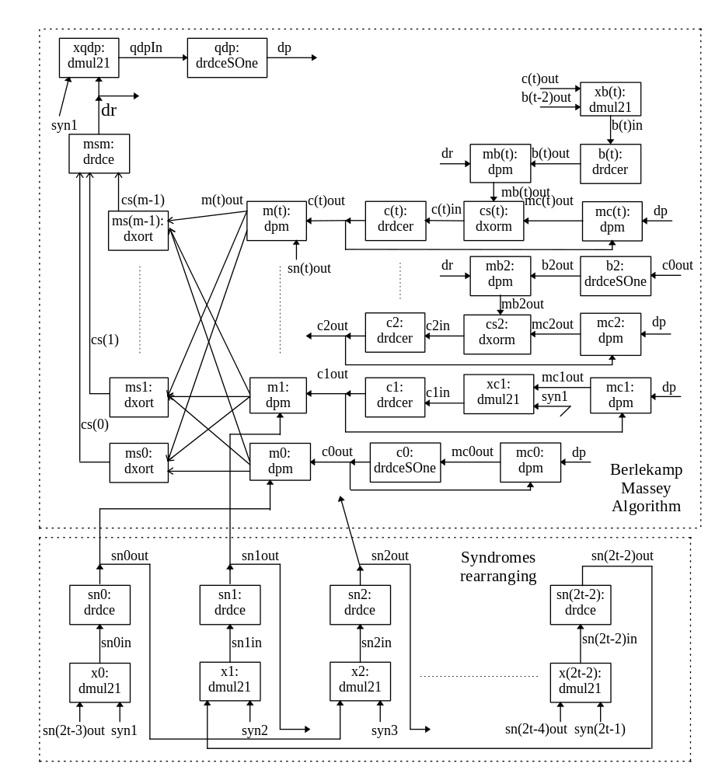The circuit for the inversionless BMA.
The fragment of the sim.txt file for the decoder of the (63, 18) 10 error correction BCH code option 2 without inversion (with design optimisation):

--------------- Syndromes calculation ------------
dsyn1 - syndromes 1 2 4 8 16
Reg= 6 XOR= 15
dsyn3 - syndromes 3 6 12
Reg= 6 XOR= 14
dsyn5 - syndromes 5 10 17
Reg= 6 XOR= 14
dsyn7 - syndromes 7 14
Reg= 6 XOR= 12
dsyn9 - syndromes 9 18
Reg= 3 XOR= 4
dsyn11 - syndromes 11
Reg= 6 XOR= 9
dsyn13 - syndromes 13 19
Reg= 6 XOR= 13
dsyn15 - syndromes 15
Reg= 6 XOR= 15
total Reg= 45 XOR= 96

--------------- Chien Search ------------
dcheq - check if Chien search equal zero - found an error
Reg= 0 XOR= 60
drdce - m registers for x^0
Reg= 6 XOR= 0
dch1 - Chien Search for x^1
Reg= 6 XOR= 1
dch2 - Chien Search for x^2
Reg= 6 XOR= 2
dch3 - Chien Search for x^3
Reg= 6 XOR= 3
dch4 - Chien Search for x^4
Reg= 6 XOR= 4
dch5 - Chien Search for x^5
Reg= 6 XOR= 5
dch6 - Chien Search for x^6
Reg= 6 XOR= 6
dch7 - Chien Search for x^7
Reg= 6 XOR= 7
dch8 - Chien Search for x^8
Reg= 6 XOR= 7
dch9 - Chien Search for x^9
Reg= 6 XOR= 7
dch10 - Chien Search for x^10
Reg= 6 XOR= 7
total Reg= 66 XOR= 109

--------------- Syndromes rearranging ------------
dmul21 - 2 to 1 multiplexers
Reg= 0 * 19 = 0 XOR= 0 * 19 = 0
drdce - m registers with clock enable
Reg= 6 * 19 = 114 XOR= 0 * 19 = 0
total Reg= 114 XOR= 0

--------------- Berlekamp-Massey Algorithm ----
dmul21 - 2 to 1 multiplexers
Reg= 0 * 9 = 0 XOR= 0 * 9 = 0
drdceSOne - m registers with set to one
Reg= 6 * 4 = 24 XOR= 0 * 4 = 0
drdcer - m registers with reset
Reg= 6 * 16 = 96 XOR= 0 * 16 = 0
dxorm - m * XOR - modulo 2 addition
Reg= 0 * 9 = 0 XOR= 6 * 9 = 54
dpm - bit-parallel standard basis multiplier option L
Reg= 0 * 31 = 0 XOR= 35 * 31 = 1085
dxort - modulo 2 addition
Reg= 0 * 6 = 0 XOR= 9 * 6 = 54
drdce - m registers
Reg= 6 * 2 = 12 XOR= 0 * 2 = 0
total Reg= 132 XOR= 1193

--------------- The buffer ----
dbuf - buffer for storing data to be corrected
Reg= 37 XOR= 1
total Reg= 37 XOR= 1

--------------- The control system ----
dca - less significant control counter
Reg= 2 XOR= 1
dcb - more significant control counter
Reg= 5 XOR= 4
dcl - degree of error polynomial
Reg= 4 XOR= 5
drd1ce - single register
Reg= 1 * 5 = 5 XOR= 0 * 5 = 0
dcount - control system
total Reg= 16 XOR= 10

DECODER total
Reg= 410 XOR= 1409

The design simulation
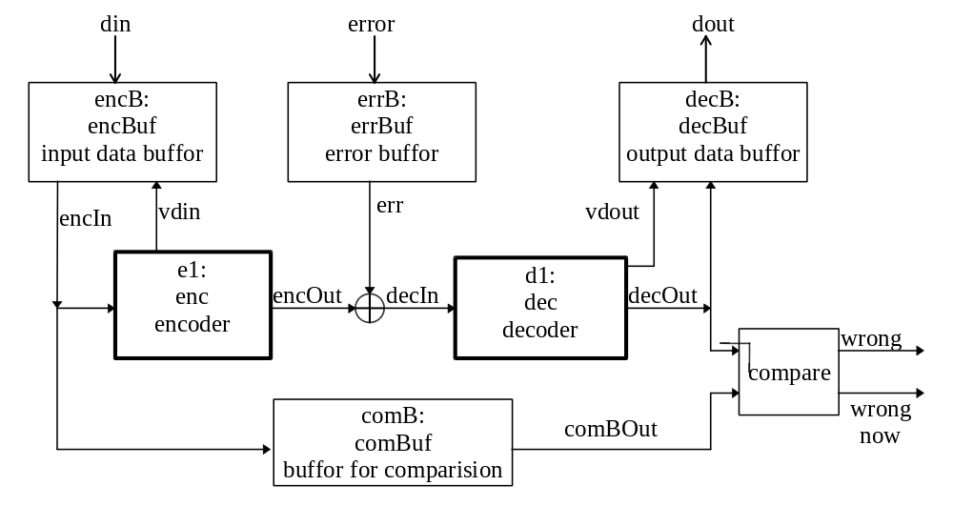
The circuit for simulation included in the sim.vhd file.

The din and error vectors are generated by the C program and exported into the sim.cmd and sim.cme simulation command file. Then these vectors are converted into serial form in encBuf and errBuf circuit. Accordingly the decBuf converts serial data corrected by the decoder into the parallel output vector. There are two different signals indicating a faulty circuit:
- wrongNow - the high state indicates that signal decOut is faulty at the time
- wrong - the high state indicates that at least one state of the decOut signal has been faulty.

